1. Match the pictures with the words in the box and then classify the words:

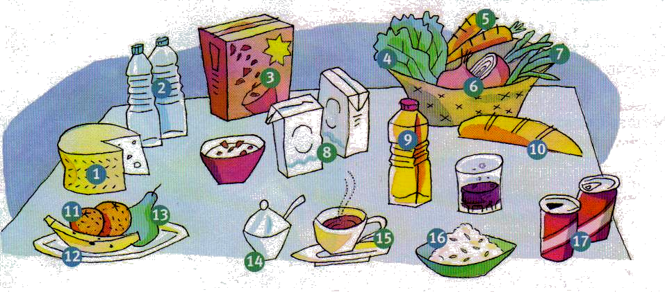

Fruit | Vegetables | Drink | Other
 |  |  | Cheese

Water coffee cereals cheese banana beans onions bread milk cola carrots oil rice lettuce pear oranges sugar

2. Look at the picture again and write sentences with a (n), some or any:

Example: There are some oranges.

- oranges
- tea
- coffee
- bread
- beans
- fish
- bananas
- carrots

3. Make the nouns in column B countable by using the words in column A.

A bottle of
A cup of
A packet of
A loaf of
A carton of
A slice of

Bread
Pasta
Wine
Cheese
Coffee
Milk
A
B

4. Copy and complete the sentences with a little or a few :

Example: I am going to drink a little water.

- There is only ______________ coffee in the cup.
- There are ________________oranges in the picture.
- We only bought ________________carrots yesterday.
- We’ve got ___________________ milk in the kitchen.
- I’m going to the supermarket to buy _________________ cartons of milk.

